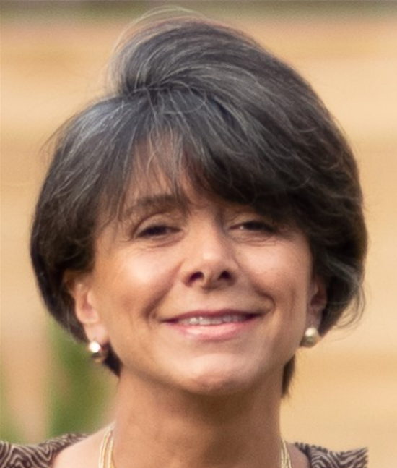
Marília Duffles brings a wealth of experience and a different perspective to Shadow Politics.

MARÍLIA DUFFLES is the
new cohost of SHADOW POLITICS with United States Senator Michael D. Brown (D-DC) on
BBS Radio and We Act Radio

A scientist with a degree in microbiology from the University of Maryland and work in virology, Marília is also well versed in politics – having been a political appointee serving in the administrations of President Ronald Reagan and President George H.W. Bush.

She is an accomplished journalist contributing to publications such as the Financial Times, The Economist and Huff Post.

A Republican turned Independent, Marília brings a fresh, different and important perspective to the show.

Marília does charity work in Africa and India and was a ballet dancer with the National Ballet of Washington, DC.

Marília has a fascinating and diverse background. Originally from Brazil, she speaks four languages and has lived in Europe and South America. She lived in Hawai'i for 15 years and traveled extensively throughout Africa, Asia and the Pacific Islands. She currently resides in the nation’s capital where she has lived on and off for many years.

