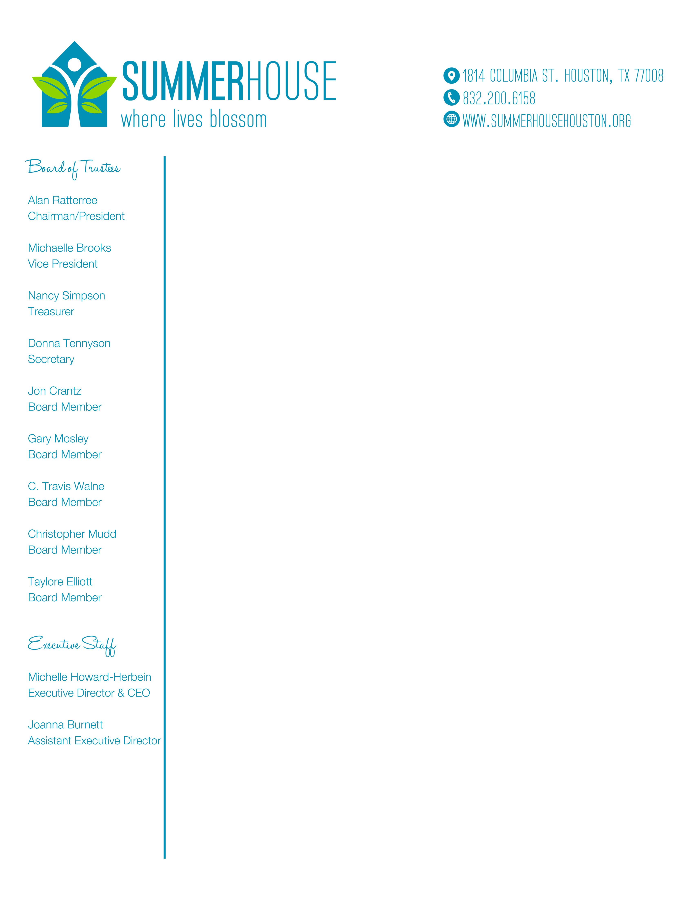

To whom it may concern,

Summerhouse Houston is a local nonprofit that exists to create personal growth opportunities for young adults with intellectual disabilities. We offer inclusive, community-based programming to assist members in achieving their own vocational, social, and independent living goals.

Shred for Independence is our member-owned and operated shredding business where Summerhouse members develop valuable work skills. Shred for Independence makes an impact by:
- Recycling over 24,000 pounds of shredded paper each year
- Providing shredding services to over 30 businesses in Houston
- Creating jobs for young adults with intellectual disabilities

To address a vast need for meaningful adult services in our community, we are growing and need your support! To reach our goal of doubling the impact of Shred for Independence by Summer 2020, we will need to secure ten more shredders.

Please consider sponsoring one $2,500 shredder to help our members and their business thrive! Sponsoring businesses or individuals will be recognized in our shredding room at our new location in Spring Branch.

For inquiries or to make your donation, please contact Joanna Burnett at 832-200-6158 ext. 2 or joanna@summerhousehouston.org.

Sincerely,
Summerhouse Houston
Shred for Independence

To learn more about Shred for Independence, visit www.shredforindependence.com
@shredforindependence

